**CHANGES SUGGESTED:**

I have implemented the changes suggested in the class. Below are the screenshot of it:

1. DEDUG is set to false which is show the page not found error if invalid URL is accessed.

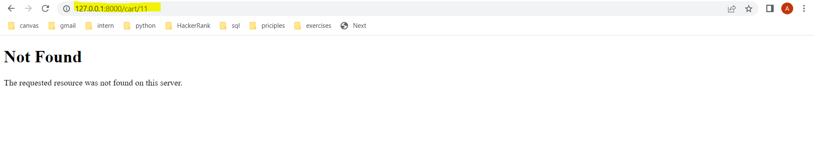

1. Tax module with CGST(9 %) and SGST(7%) has been implemented.

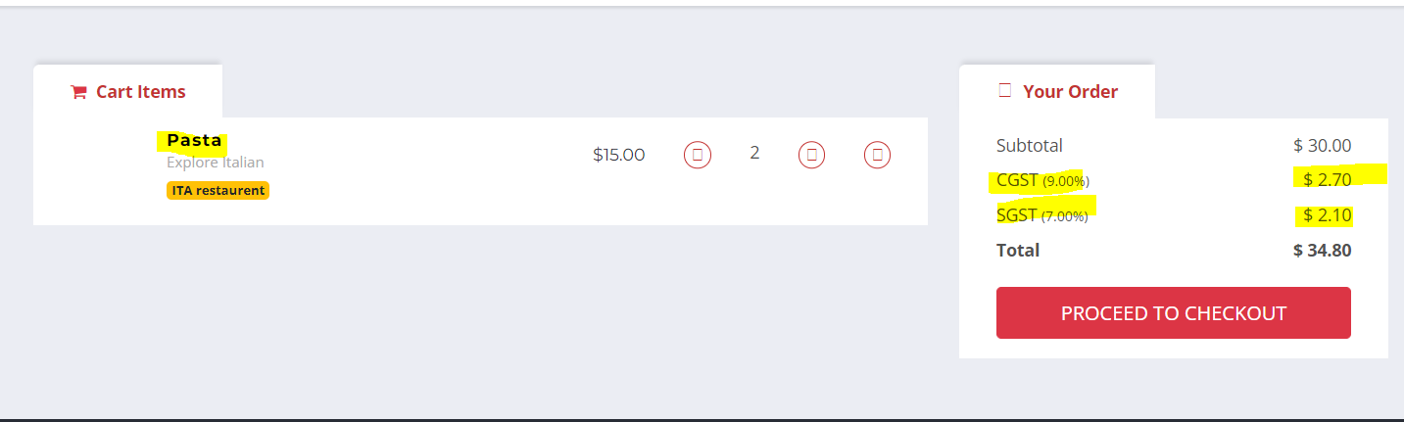

1. Footer is changed.

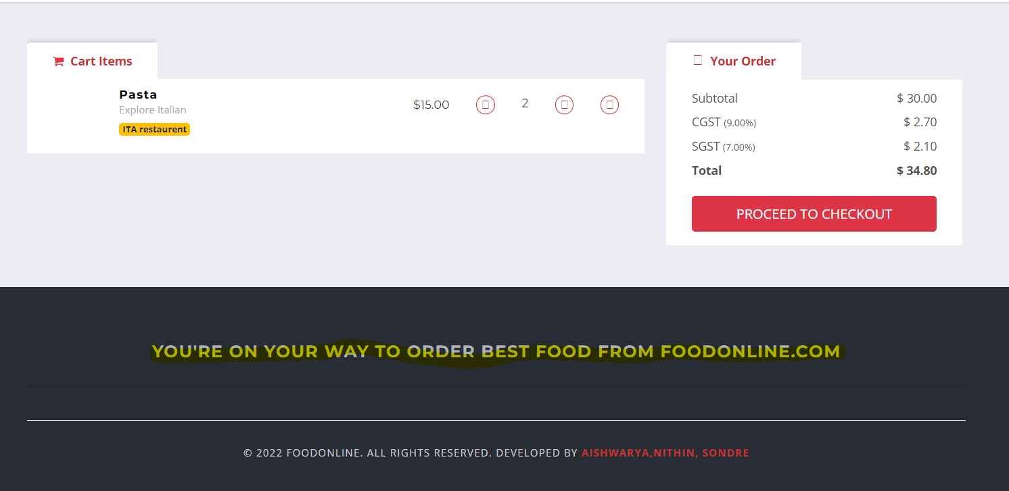

1. The width of the images that will be loaded as the vendors register their new restaurant is fixed.

